* Page 1

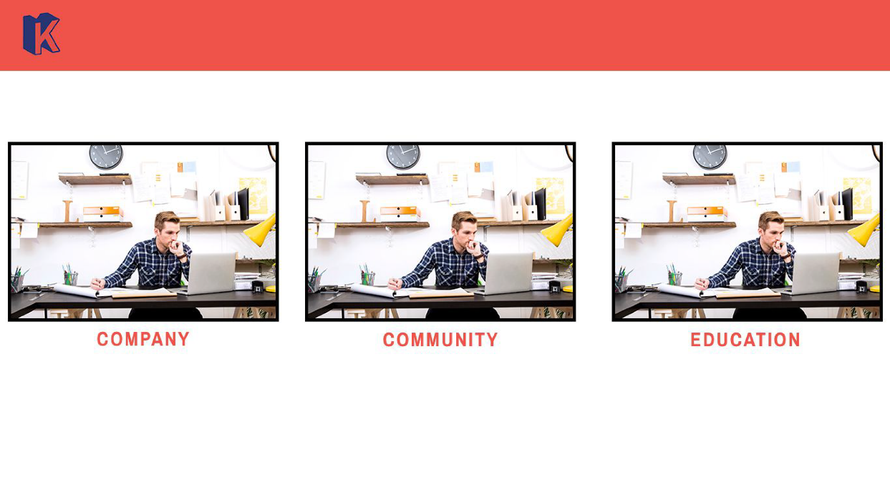

ERD:

category

- id (PK) (int)

- category_type (VARCHAR 32)

- image_url (VARCHAR 255)

attribute_category

- id (PK) (int)

- categoryID (FK) (int)

- name (VARCHAR 32)

- url_image (VARCHAR 255)

- description (VARCHAR 255)

API

Api Name : Get List Category

Url = {url}/api/category/list

Requestparameter : none

Requestbody : none

Response

{

“status”: 200

“message”: “OK”

“result”:[{

“id”: 1,

“category_type”:”company”,

“url_image”:”image.com”

},{

“id”: 2,

“category_type”:”education”,

“url_image”:”image.com”

}

]

}

Query: select * from category

* Page 2

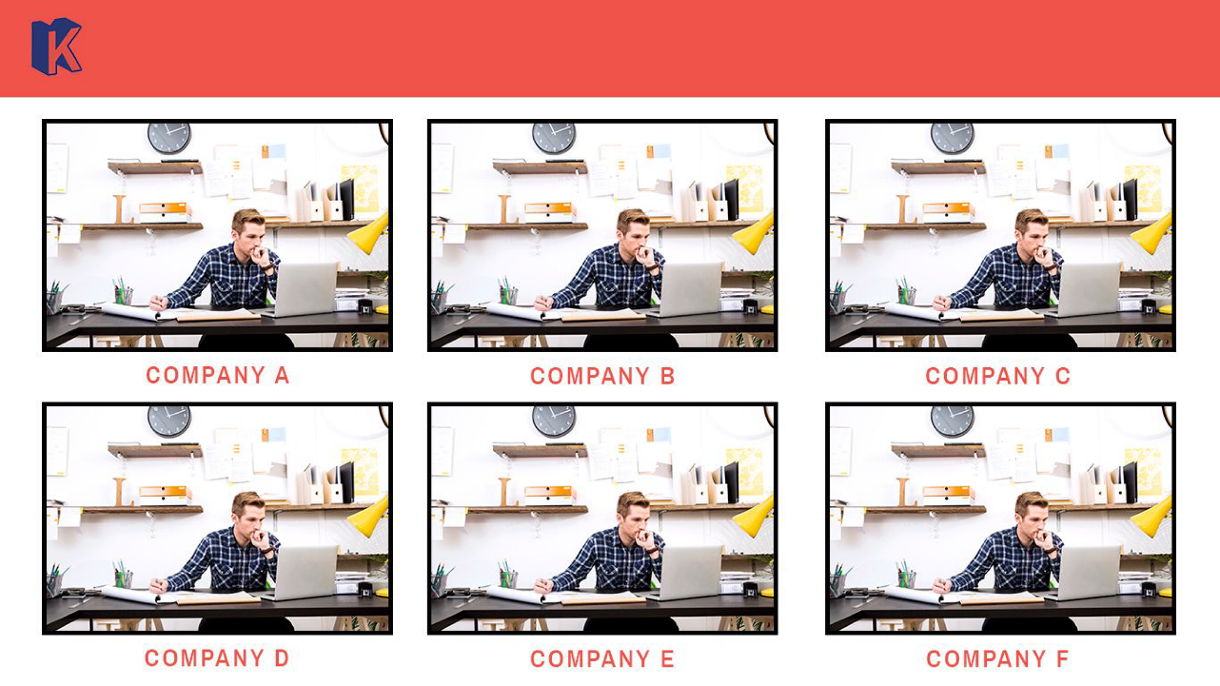

API Name: get list company

Url : {url}/api/category/list?type=”education”

requestParameter:

type = [String]

requestBody: none

Response:

{

“status”: 200

“message”: “OK”

“result”:[{

“id”: 1,

“categoryID”:1,

“name”: “Company A”,

“url_image”:”image.com”,

“description”:”description”

},{

“id”: 2,

“categoryID”:2,

“name”: “Company B”,

“url_image”:”image.com”,

“description”:”description”

}

]

}

Query = select * from attribute_category as ac inner join category as c on ac.categoryID = c.id where ac.category_type = :type;

* Page 3

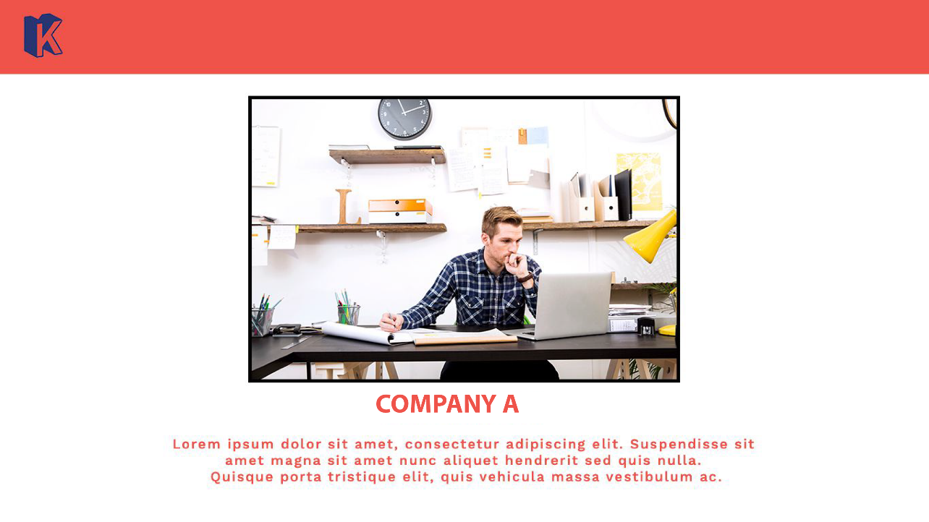

Api Name : Get Detail Company

Url : {url}/api/company/detail?id=”1”

requestParameter:

id = [int]

requestBody: none

Response:

{

“status”: 200

“message”: “OK”

“result”:{

“id”: 1,

“categoryID”:1,

“name”: “Company A”,

“url_image”:”image.com”,

“description”:”description”

}

}

Query = select * from attribute_category as ac inner join category as c on ac.categoryID = c.id where ac.category_type = :company and c.categoryID = :categoryID;